**Report on Git and GitHub**

Git is what we call version control system which is open source and widely used version system in development. Version control is the management of changes to documents, computer programs, large web sites, and other collections of information. When it comes to GitHub it is a repository hosting service for Git where it provides graphical interface.

**Learning Git and GitHub:**

* On the GitHub web page we will first have to get registered for GitHub account by providing the necessary details (username, Email address, and password). Get your account verified after the registration. Since I already had my GitHub account I got signed in to my account.

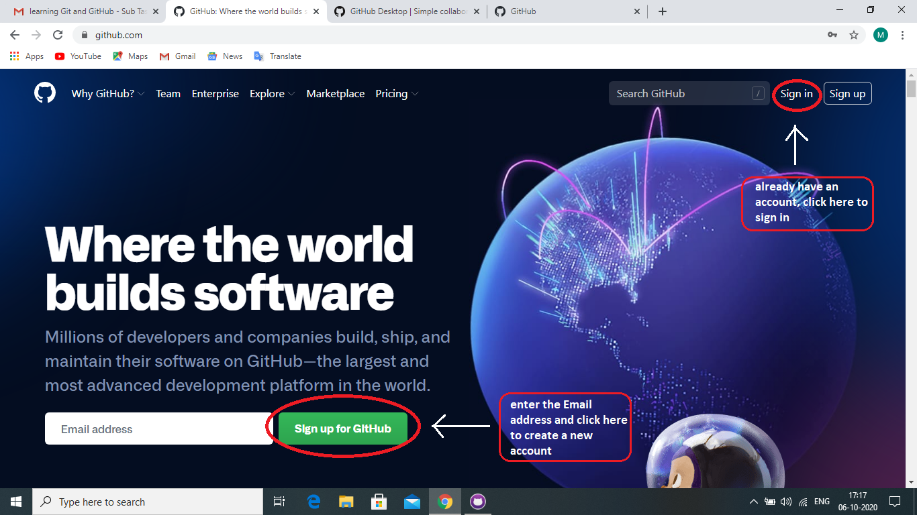

On signing in to the account the landing page looks as shown in the image below.

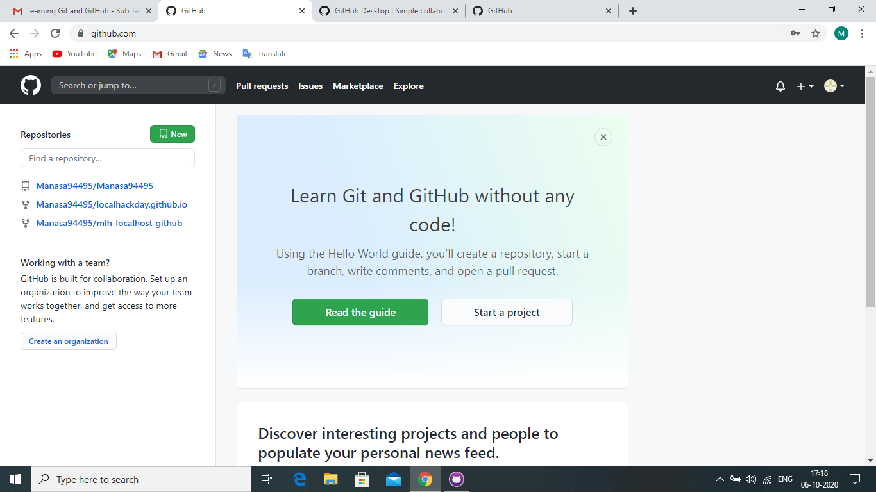

* Install git client software on the system through git-scm.com web page.

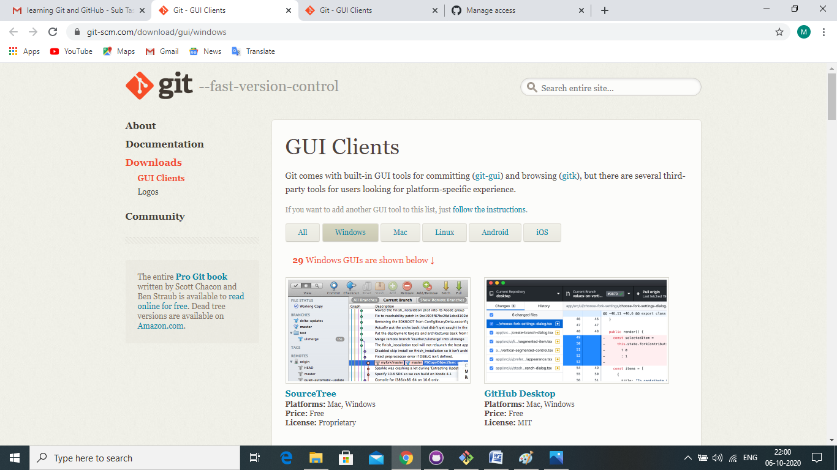

On selecting the operating system install any of the GUI available on the web page. Once the installation is being done login to the client software using the GitHub ID.

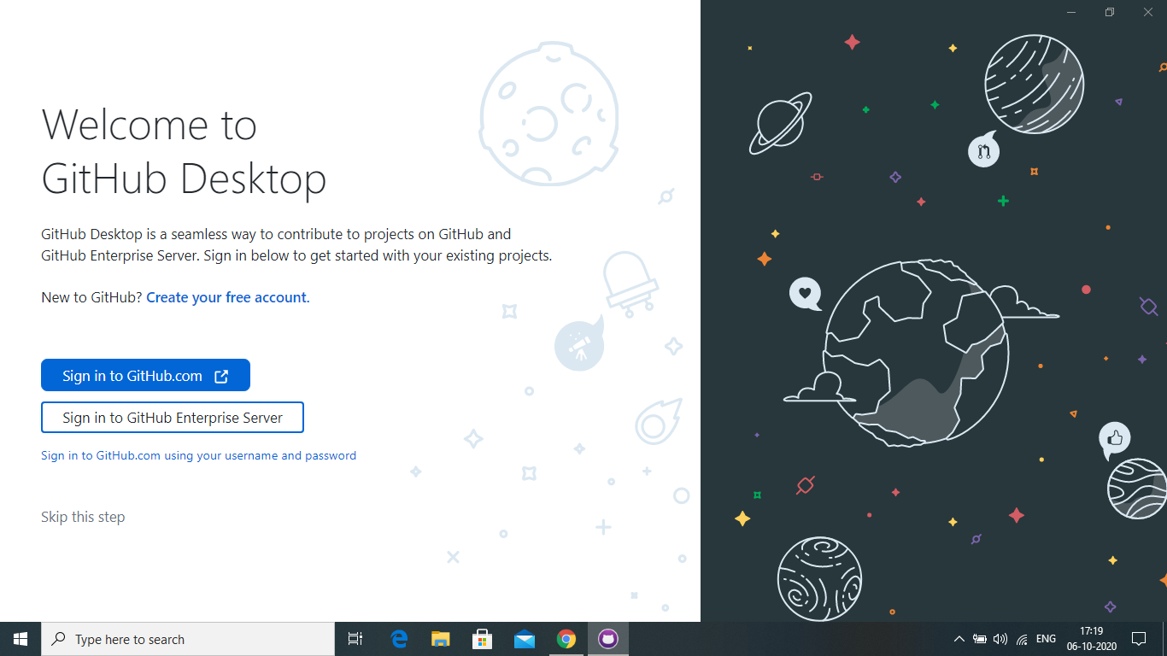

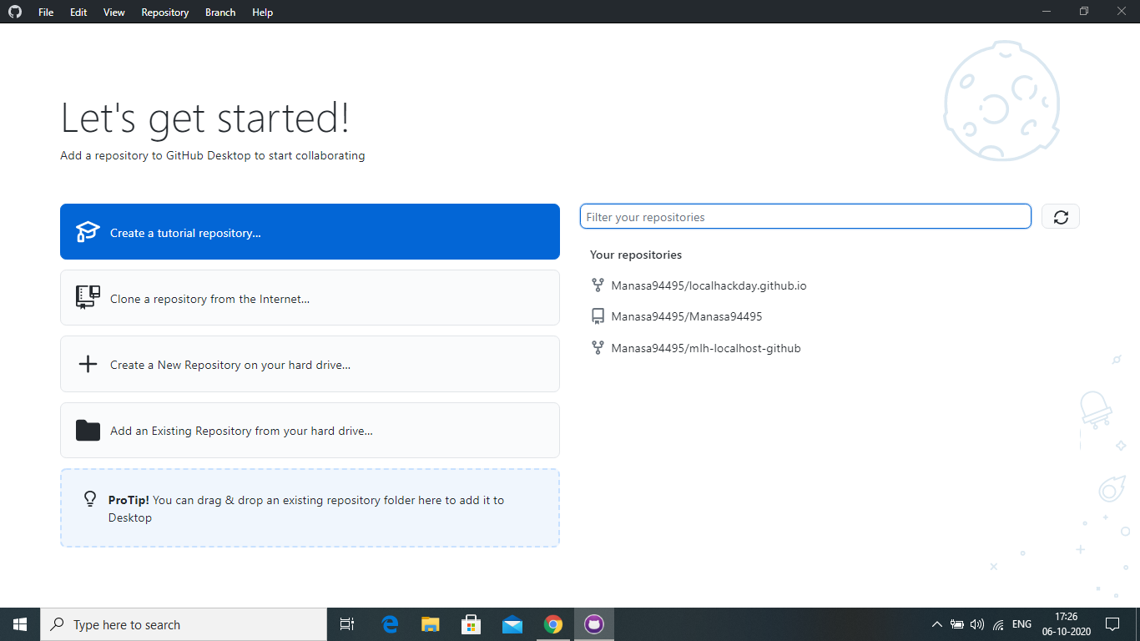

* We will now have to create a local repository on the system using git init command on the command prompt of GitHub (Git bash).

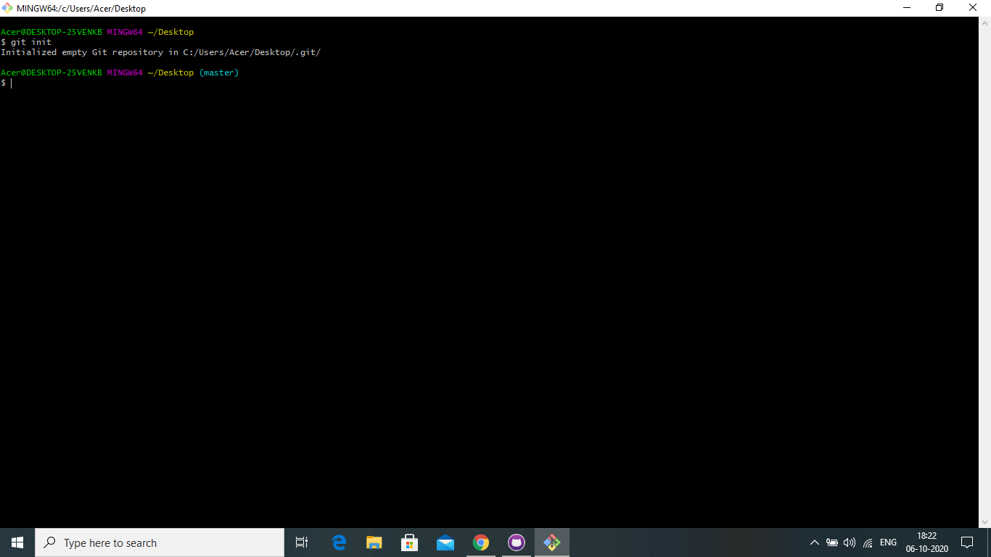

* On your Github account create a new repository with any name and make the repository public. Check the check box which says add README file and click on create repository.

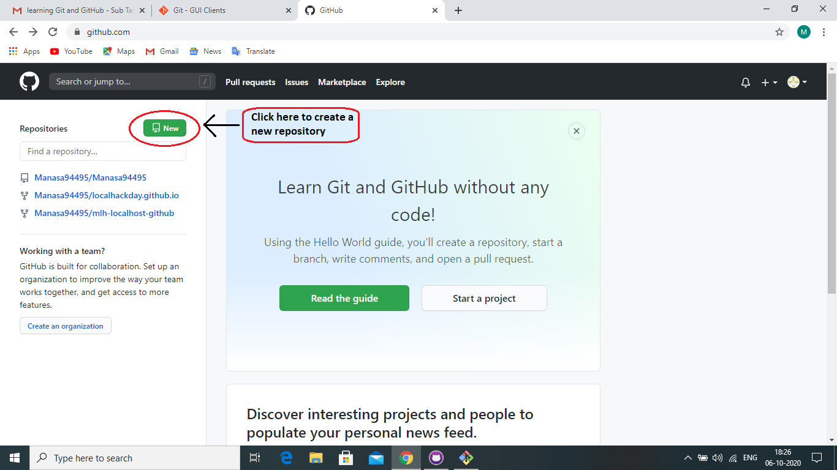

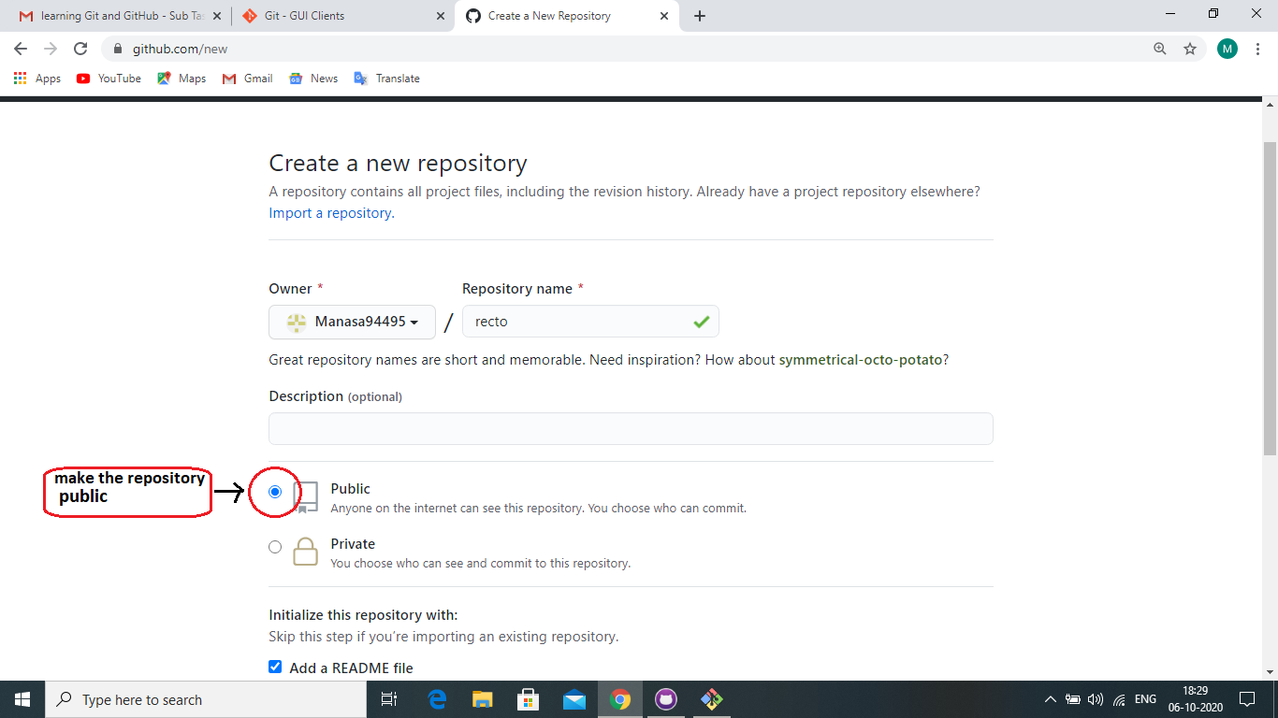

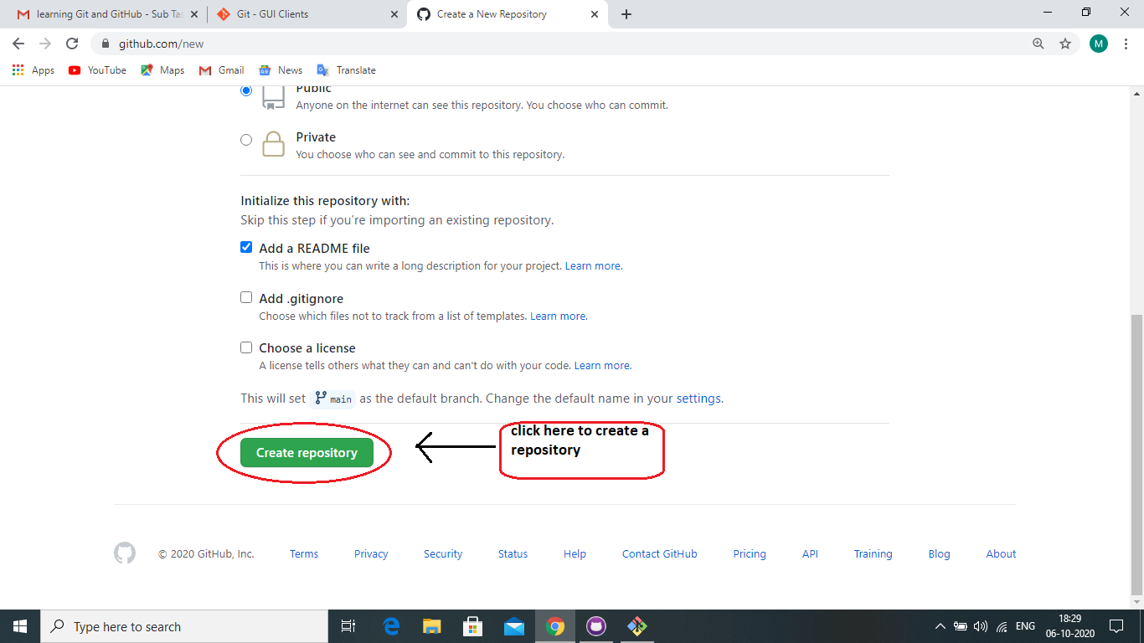

* After creating a new repository, click on settings>manage access>Invite a collaborator. And add [rectopage.india@gmail.com](mailto:rectopage.india@gmail.com) as a collaborator.

